FACIAL RECOGNITION

AYOMIDE OTINWA: Role(s)

BABYSOWJANYA DAMARLA

Date of Submission: 11/12/2024

# Executive Summary

This report documents the development of a facial recognition system utilizing a Raspberry Pi, designed to capture images, train a recognition model, and perform real-time face detection. The project aimed to explore the potential of facial recognition for practical applications such as personalized access control and attendance monitoring.

The project involved three key stages: image acquisition, model training, and real-time recognition. Using the Raspberry Pi Camera and the picamera2 module, images were captured and stored in a structured dataset. OpenCV headless was employed to resolve compatibility issues with other libraries, ensuring efficient image processing. The training phase utilized the “face_recognition” library to extract facial embeddings from the dataset. These encodings, coupled with corresponding labels, were serialized into a file for use during the recognition phase.

For real-time facial recognition, the system compared live camera feed data with the pre-trained encodings. A GUI created with tkinter displayed recognized faces or indicated "Unknown" for unrecognized individuals, enhancing user interaction.

The project faced challenges such as library compatibility and environmental factors like inconsistent lighting. These were mitigated through adaptive software configurations and robust hardware integration.

Results demonstrated the system’s ability to reliably recognize faces from the dataset in real-time, with a user-friendly interface. The report concludes that the project successfully achieved its objectives and outlines future enhancements, such as integrating deep learning models for improved accuracy and extending functionality to multi-user environments.

This work showcases the feasibility of deploying facial recognition on resource-constrained devices, emphasizing its potential for cost-effective and scalable solutions in various domains.

Table of Contents

Executive Summary 1

Introduction 3

System Design 5

Overview of System Architecture 5

System Diagram 5

Description: System Architecture 5

Sensors Integration 6

AI and Edge Computing Techniques 7

User Interaction (UI/UX Design) 9

Implementation 10

Development Process 10

Methodologies Used 11

Key Code Snippets and Algorithms 11

Tools, Libraries, and Frameworks Used 14

Challenges and Solutions 15

Ethical and Societal Considerations 16

Data Security and Privacy 16

Legal Implications 17

Societal Impact and Accessibility 17

Conclusion and Reflection 18

References 20

Appendices 20

# Introduction

Background

Ubiquitous computing has emerged as a cornerstone of modern technology, enabling seamless interaction between people and their environments. Among the many applications of ubiquitous computing, facial recognition systems have gained prominence for their utility in security, personalization, and automation. These systems use computer vision techniques to identify or verify individuals based on their facial features, offering a non-intrusive, efficient solution for authentication and monitoring.

Facial recognition systems have evolved significantly since their inception in the 1960s. Geometric modeling of face traits, including the distances between eyes and the jawline's form, was the foundation of early methods. Principal Component Analysis (PCA), first presented by Kirby and Sirovich (1990), greatly increased computer efficiency by expressing faces as linear combinations of orthogonal components. A significant advancement in face detection and recognition was made possible by this fundamental technique, which made it possible to create increasingly complex models like eigenfaces (Turk & Pentland, 1991).  
  
Methods changed from human feature extraction to automated procedures with the introduction of machine learning. Convolutional Neural Networks (CNNs) and deep learning in general have revolutionized the field. Taigman et al. (2014) presented DeepFace, a model that used deep neural networks to verify faces with accuracy close to that of a human. FaceNet (Schroff et al., 2015) improved this further by using triplet loss, a novel method for producing reliable face embeddings for tasks involving recognition and grouping.

Facial recognition systems still face a number of difficulties in spite of these developments. Performance in uncontrolled situations is nevertheless hampered by variations in illumination, posture, and occlusions. Furthermore, bias and fairness difficulties have been well demonstrated. Significant differences in accuracy between demographic groups were shown by Buolamwini and Gebru (2018), underscoring the necessity of fairness in model construction. Concerns about privacy have been heightened by these difficulties, especially in light of surveillance and data collecting without express agreement.  
  
The creation of lightweight, interpretable models and ethical issues are the main focuses of current advancements in the discipline. To improve accuracy and security, attempts are also being made to combine facial recognition with other biometric modalities, like voice and fingerprint recognition. These methods seek to overcome the current drawbacks and increase the range of applications for facial recognition software in various fields.

This project focuses on implementing a facial recognition system using a Raspberry Pi, an affordable and compact computing device. Despite the growing popularity of facial recognition, deploying such systems on resource-constrained devices presents challenges in terms of computational efficiency and real-time performance. By leveraging the Raspberry Pi, this project aims to create a cost-effective, scalable solution for personal use cases, such as home security or automated attendance tracking.

Objectives

The primary objectives of this project are:

1. To develop a facial recognition system capable of capturing, storing, and processing images for training and real-time detection.
2. To explore the feasibility of deploying such a system on a Raspberry Pi, focusing on computational efficiency and practical implementation.
3. To enhance user interaction by providing a user-friendly interface that dynamically displays recognized faces.
4. To address compatibility challenges and optimize the integration of essential software libraries for seamless operation.

Scope

The project is confined to:

* Using a single-user dataset for recognition.
* Employing the picamera2 module for image acquisition and the face_recognition library for feature extraction and comparison.
* Implementing real-time recognition with a simple GUI built using tkinter.
* Utilizing the Raspberry Pi Camera and the OpenCV headless library to minimize graphical conflicts.

The system does not include advanced deep learning-based facial recognition models, multi-user datasets, or complex security integrations, focusing instead on demonstrating the fundamental capabilities of a lightweight, single-board computer.

Significance

Facial recognition technology has a profound impact on security, access control, and personalization. While commercial systems often rely on high-powered servers or cloud computing, this project demonstrates that similar functionality can be achieved on a cost-effective, resource-constrained device. Such systems have potential applications in remote areas, low-budget implementations, and educational environments where expensive hardware is impractical.

By successfully developing and deploying this system, the project highlights the possibilities of extending ubiquitous computing to resource-limited scenarios. This approach aligns with global trends toward affordable, localized technology solutions and emphasizes the democratization of advanced technologies.

# System Design

## Overview of System Architecture

### System Diagram

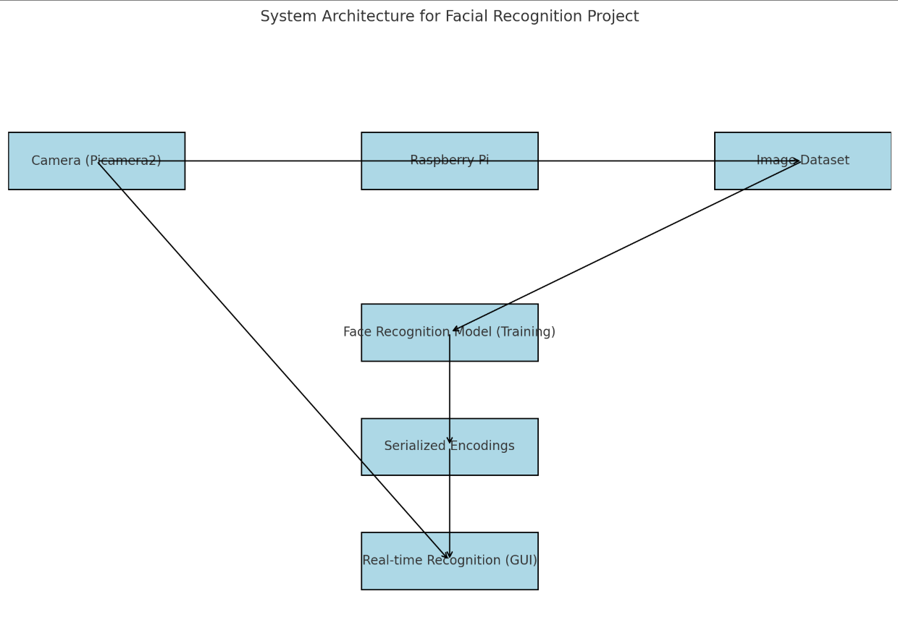

Fig. 1. System Diagram

### Description: System Architecture

The facial recognition system's architecture integrates multiple components, each designed to perform a specific role in achieving real-time facial recognition. Below is an explanation of how the components interact within the system:

1. **Camera (Picamera2)** The Picamera2 module is responsible for capturing live video feeds or still images of the subject. It serves as the primary input device, providing data to be processed for facial recognition.
2. **Raspberry Pi** This serves as the central processing unit, running the entire application. It hosts the OpenCV and face recognition libraries and manages communication between components. The Raspberry Pi also processes the images captured by the camera.
3. **Image Dataset** Captured images are stored in a structured folder system, organized by individual labels. This dataset serves as the foundation for training the face recognition model. Each subfolder contains multiple images of the same person to improve model accuracy.
4. **Face Recognition Model (Training)** Using the images in the dataset, a machine learning model is trained to encode facial features into numerical representations. This step uses the HOG (Histogram of Oriented Gradients) face detection model to locate and encode faces. Encoded faces are then serialized and saved as a pickle file for future use.
5. **Serialized Encodings** The pickle file stores facial embeddings and associated labels, allowing the system to recognize faces without retraining the model. This ensures efficient recognition in real-time.
6. **Real-time Recognition (GUI)** The user interface, developed using Tkinter, displays live camera feeds and recognized names. It integrates with the face recognition module to detect, match, and display the identity of individuals in real time.

## Sensors Integration

#### List of Sensors Used

The **Raspberry Pi Noir Camera V2** was the sole sensor used in this facial recognition project. This camera module was selected for its high-quality imaging capabilities and compatibility with the Raspberry Pi platform.

#### Functionality

1. **Raspberry Pi Noir Camera V2**
   * **Purpose**: The camera captures images and video streams in real-time, serving as the primary input for the facial recognition system.
   * **Key Features**:
     + 8-megapixel resolution for clear facial details.
     + Infrared sensitivity, allowing use in low-light environments.
   * **Role**: The camera detects and captures faces, providing the raw image data required for subsequent processing and recognition.

#### Data Acquisition

1. **Data Collection**
   * The camera continuously captures live video feeds or still images during operation. For dataset creation, it was configured to save images in a predefined directory, organized by subject name.
2. **Processing**
   * Captured images are processed using the **Picamera2** module, converting frames into arrays suitable for OpenCV operations.
   * Frames are either saved to disk for training or directly passed to the face recognition pipeline during real-time detection.
3. **Usage in the System**
   * **Training Phase**: Images captured during this phase are stored in a dataset. The face recognition model uses these images to extract and encode facial features into embeddings.
   * **Real-Time Recognition**: During live operation, frames are processed, and the system compares detected faces against stored embeddings to identify individuals.

#### Diagram Suggestion: Flowchart



Fig. 2. Flowchart Diagram of the project

## AI and Edge Computing Techniques

#### AI Models Implemented

The facial recognition project implemented the face_recognition library, which uses a pre-trained Deep Neural Network (DNN) to encode and match faces.

Algorithm Used:

The underlying model leverages Histogram of Oriented Gradients (HOG) for face detection, with options for a Convolutional Neural Network (CNN) for enhanced accuracy.

Facial recognition operates by encoding facial features into 128-dimensional embeddings using a neural network pre-trained on large face datasets like Labeled Faces in the Wild (LFW).

##### Key Steps in the AI Pipeline:

* Face Detection: Locates the face within an image or video frame using the HOG or CNN model.
* Feature Extraction: Converts facial landmarks into a feature vector encoding.
* Face Matching: Compares new face encodings against a database of pre-stored embeddings using Euclidean distance.

#### Edge Processing

The **Raspberry Pi 4 Model B**, paired with the **Picamera2 library**, was employed to process AI tasks on the edge device, ensuring real-time performance and local processing.

##### **Processing Workflow**:

1. **Data Capture**: The Pi Noir Camera V2 captures frames, either continuously or triggered, and streams them to the Pi's processor.
2. **Preprocessing**: OpenCV converts images from BGR to RGB format and scales them to appropriate dimensions, reducing computational overhead.
3. **Inference**: The face recognition library computes embeddings and compares them with the trained dataset.
4. **User Interface**: Results (e.g., recognized names) are displayed via a GUI built with Tkinter.

##### **Edge Benefits**:

* **Reduced Latency**: On-device computation eliminates cloud dependency, enabling faster recognition.
* **Privacy**: Sensitive data, such as facial images, remains local to the device.

#### Optimization Strategies

To ensure efficient processing on the resource-constrained Raspberry Pi, the following strategies were implemented:

1. **Model Selection**:
   * The HOG-based face detection was chosen for its computational efficiency compared to CNNs.
   * The pre-trained embeddings were lightweight, ensuring fast matching against known faces.
2. **Hardware Utilization**:
   * Leveraging the **ARM Cortex-A72 processor** on the Raspberry Pi, multithreaded processing was used to handle image capture and AI inference in parallel.
   * GPU acceleration was avoided to conserve power.
3. **Image Resolution**:
   * Frames captured were downscaled to 320x240 pixels, maintaining recognition accuracy while reducing processing time.
4. **Memory Optimization**:
   * **OpenCV-Headless** was employed to prevent unnecessary GUI conflicts, ensuring smooth execution.
5. **Efficient Libraries**:
   * Picamera2 replaced traditional camera modules, streamlining image capture and enabling integration with AI pipelines.

#### Block Diagram

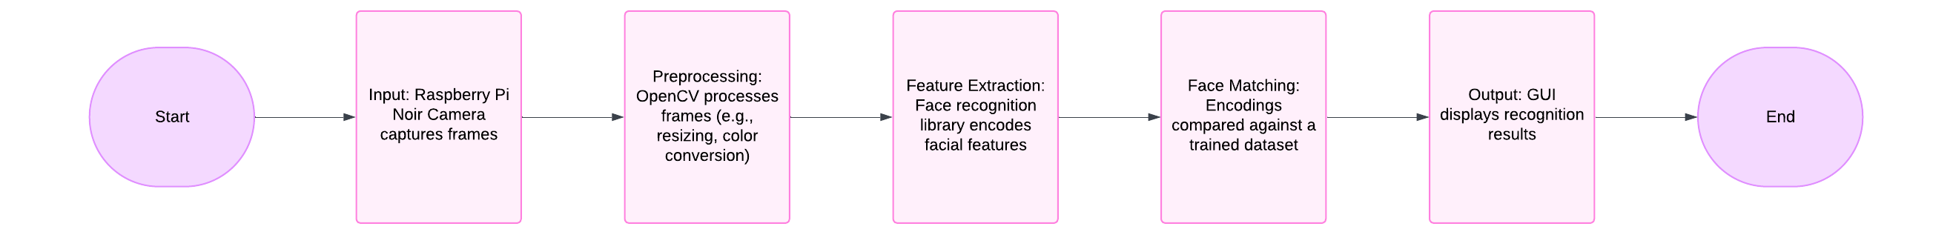Fig. 3. Block Diagram of the workflow

## User Interaction (UI/UX Design)

Interface Design  
The user interface (UI) of the facial recognition system is designed to be simple, intuitive, and responsive, providing a seamless interaction for users. The main interface consists of a camera feed window, where users can view live images captured by the Raspberry Pi Noir Camera. The interface is built using Tkinter, allowing for easy integration with Python and Raspberry Pi.

##### Main Features:

* Live Camera Feed: The camera feed is displayed in real-time to allow users to view their face while the system is active.
* Recognition Feedback: Once a face is recognized, the system displays a greeting message such as "Welcome, [name]." If an unrecognized face is detected, it will show "Unknown."

User Experience (UX)  
The design prioritizes ease of use by ensuring that the user experience (UX) is smooth and engaging. Key elements include:

* Immediate Feedback: The system provides immediate visual feedback upon recognition. This reduces user frustration, as they can see the result of their action right away.
* Minimal Interaction: Users only need to stand in front of the camera and allow the system to do the rest. The design does not require manual input during face detection, which keeps the experience simple and hassle-free.
* Clear Instructions: The UI offers clear text prompts such as "Detecting..." and "Welcome [name]" to guide users, ensuring that they understand what is happening at each stage.

Accessibility Features  
To ensure the application is accessible to a wide range of users, the following features are incorporated:

* Large Font Size: The font used for text, such as greetings and status updates, is large and easy to read, improving visibility for users with visual impairments.
* Simple Design: The layout is minimalistic, avoiding clutter and ensuring that users of all ages can navigate it easily.
* Color Contrast: High-contrast color schemes used to ensure that text is readable under various lighting conditions.

# Implementation

## Development Process

The development of the facial recognition system spanned over a period of three months, with each stage carefully planned and executed to ensure smooth progression from concept to completion. The following outlines the key stages of the project:

1. Planning and Research (Weeks 1-2):
   * This initial phase involved understanding the project’s requirements, researching suitable tools and libraries (e.g., OpenCV, face_recognition, Picamera), and setting up the Raspberry Pi environment.
   * Decisions were made regarding the use of the Raspberry Pi Noir Camera, the configuration of the AI algorithms for facial recognition, and the development of the user interface (UI).
2. Data Collection and Preprocessing (Weeks 2-3):
   * During this phase, data collection was carried out by capturing images of the user for the training dataset. The code for saving images was implemented, and the dataset was organized in folders for each individual.
   * Data preprocessing was performed to prepare the images for facial recognition, which involved converting images into a suitable format for the AI model.
3. Model Training and Testing (Weeks 3-4):
   * The facial recognition model was trained using the collected images, and encodings were generated for each individual.
   * Testing was done to ensure that the model could accurately recognize faces by comparing live camera feeds with the stored encodings.
4. System Integration and UI Development (Weeks 4-6):
   * The user interface was developed using Tkinter, and integrated with the facial recognition system to provide a real-time feedback loop.
   * The system was tested for efficiency and usability, ensuring that the application provided quick recognition and an intuitive user experience.
5. Optimization and Finalization (Weeks 7-12):
   * Performance optimizations were carried out to reduce lag and improve recognition accuracy.
   * The final user interface and system were tested in various environments, and bug fixes were implemented based on testing feedback.

Methodologies Used  
The development process followed an Agile methodology, with iterative stages that allowed for continuous feedback and improvement. This approach enabled adjustments to be made throughout the project, ensuring the final product met both functional and user experience requirements. Regular testing and refinements were made after each milestone to ensure the system was operating optimally before moving to the next phase.

## Key Code Snippets and Algorithms

##### Code Highlights:

1. Image Capture and Data Saving (Using Picamera2 and OpenCV): This snippet captures images from the Raspberry Pi camera and saves them to the specified dataset directory. It is key to the data collection process for training the facial recognition model.

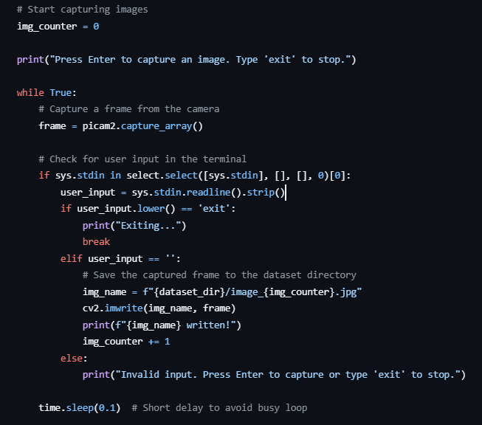

**Explanation:**

* The code utilizes Picamera2 for Raspberry Pi camera control and cv2 for displaying and saving images.
* Each image is saved with a unique name (e.g., image_0.jpg, image_1.jpg) in the dataset folder for training purposes.
* The loop allows continuous image capture, triggered by the space bar. Pressing ESC exits the program.

1. Training Facial Recognition Model (Using face_recognition Library): This snippet loads images, extracts facial encodings, and stores them for later recognition.

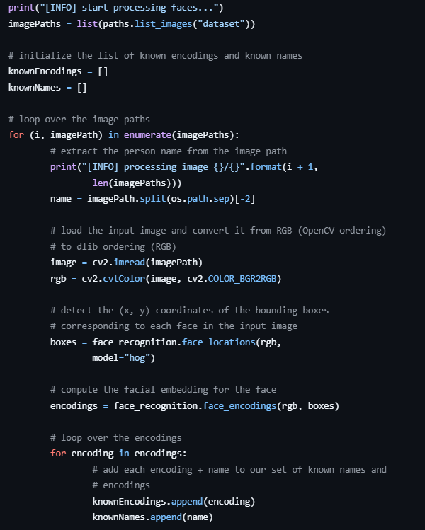

**Explanation:**

* This code loads images from the dataset, processes them to extract facial encodings using the face_recognition library.
* Each encoding is stored along with the corresponding name in a list.
* The encodings are serialized and saved into a pickle file (encodings.pickle), which will be used later for face recognition.

1. Real-Time Face Recognition (Using Picamera2 and face_recognition): This is the core code responsible for recognizing faces in real-time using the camera feed.
   1. **User Interface with Tkinter:**

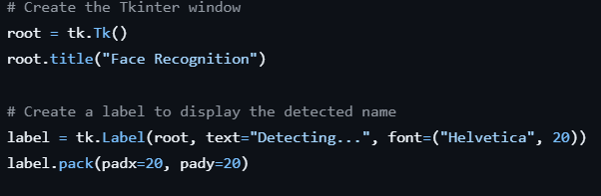

The system incorporates a user-friendly graphical user interface (GUI) built with Tkinter, a Python library for creating desktop applications. The GUI displays the name of the recognized individual or "Unknown" if the face does not match any stored encoding. This interface enhances the system's usability by providing real-time feedback during face recognition.

* Window Setup: A Tkinter window (root) serves as the main application interface, with the title set to "Face Recognition."
* Dynamic Updates: A label widget is used to display recognition results, updated dynamically using the update_label function. This ensures users receive instant and clear feedback on detected identities.
  1. **Face Recognition Logic:**

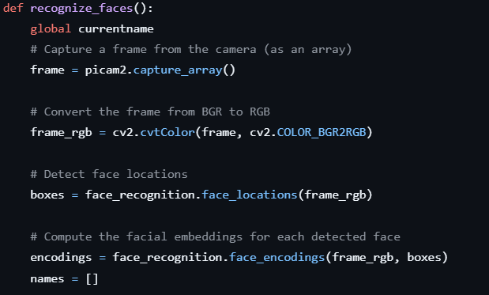

The core of the application revolves around the face recognition process, which involves capturing frames from the camera, processing them, and identifying individuals.

* Frame Capture: A single frame is captured from the Raspberry Pi camera using picam2.capture_array(). This provides a snapshot of the current scene for analysis.
* Color Conversion: The frame, initially in BGR format (default for OpenCV), is converted to RGB using cv2.cvtColor() to make it compatible with the face_recognition library.
* Face Detection: The face_recognition.face_locations() function identifies the locations of faces within the frame by returning bounding box coordinates.
* Face Encoding: Detected faces are processed using face_recognition.face_encodings() to extract unique numerical features, known as embeddings, which are essential for identifying individuals.

## Tools, Libraries, and Frameworks Used

#### Programming Languages:

* Python: The primary programming language used throughout the project due to its extensive support for computer vision, AI, and Raspberry Pi integration. Python's rich ecosystem of libraries made it ideal for this application.

#### Libraries and Frameworks:

* Picamera2: A library used for controlling the Raspberry Pi camera. It provides an easy-to-use interface for capturing still images and video streams from the camera, essential for the facial recognition system.
* OpenCV: A powerful computer vision library used for image processing and manipulation. It was employed to convert captured images to RGB format, display frames, and handle image-related tasks.
* face_recognition: This Python library simplifies the use of state-of-the-art face recognition algorithms, providing functions for detecting and recognizing faces in images and video streams. It was crucial for implementing real-time facial recognition.
* imutils: A Python package that provides simple utilities for image processing tasks, such as resizing, rotating, and displaying images.
* pickle: Used for serializing and deserializing the facial encodings and names, enabling the storage of the model after training and its loading for real-time face recognition.
* NumPy: A fundamental package for numerical computing in Python, used to handle arrays and matrix operations, often used alongside OpenCV and face_recognition for image manipulation.

#### Hardware Components:

* Raspberry Pi 4 Model B: The primary computing platform running the AI and face recognition algorithms, equipped with a quad-core ARM Cortex-A72 processor and sufficient memory (4GB or more) for real-time processing.
* Raspberry Pi Noir Camera V2: A camera module used for capturing high-quality images and video, integral for detecting and recognizing faces.
* MicroSD Card (32GB or more): Used for storing the Raspberry Pi OS, libraries, and project files.

# Challenges and Solutions

##### Technical Challenges:

1. Library Installation Issues:  
   One of the significant challenges I faced during the development was dealing with library installation issues. Several libraries required for the project, such as OpenCV and the face_recognition library, were clashing with each other. These clashes arose because different libraries required different versions of system dependencies, causing conflicts during installation.
2. Breaking System Packages:  
   To resolve the library clashes, I had to break certain system packages, which meant manually modifying system configurations to allow conflicting libraries to be installed. While this approach resolved the immediate issue, it also created potential stability concerns and required careful management to avoid damaging critical system packages.
3. Python Environment Interference:  
   Another challenge was managing Python environments. Virtual environments, which are meant to isolate dependencies for different projects, caused interference during the installation process. Sometimes, the installation of one package would disrupt or overwrite files needed by another, leading to errors and delayed progress in the development.

##### Problem-Solving Strategies:

1. Manual Package Installation:  
   To resolve the clashes between the libraries, I had to manually install some packages using specific versions that were compatible with each other. I also researched and used custom installation commands to bypass the conflicts, making sure the correct dependencies were installed in the correct order.
2. Careful Package Management:  
   Given the need to break system packages, I carefully tracked all the changes I made and ensured I could revert them if necessary. This required documenting each modification step, especially when handling critical system libraries, to minimize the risk of breaking the overall system.

##### Lessons Learned:

1. Importance of Managing Dependencies Carefully:  
   I learned that careful management of dependencies is crucial, especially when working on a system with many interconnected libraries. Using virtual environments for each task proved essential in preventing conflicts.
2. System Stability Requires Caution:  
   Breaking system packages to resolve installation issues was a risky approach. In the future, I will explore containerization tools like Docker, which could help prevent these issues by providing isolated environments without affecting the base system.
3. Testing and Troubleshooting are Key:  
   The experience taught me the importance of rigorous testing during setup and installation stages. Ensuring all libraries and packages are compatible upfront can save significant time during the actual development process.

# Ethical and Societal Considerations

## Data Security and Privacy

##### Data Handling:

In this project, the primary data being collected is visual information captured by the Raspberry Pi camera. The system processes these images to detect specific features or objects, which are essential for the project’s functionality. However, no sensitive personal data, such as names or locations, is collected by the system. The captured data is processed locally on the Raspberry Pi and is not shared externally, unless explicitly designed to do so for further analysis or debugging purposes.

The system does not store user data in a centralized database, nor does it log personal information. All data, particularly images, are handled temporarily for real-time processing, after which they are discarded unless explicitly required for analysis. This approach minimizes the risk of long-term data storage and reduces the likelihood of unauthorized data access.

##### Privacy Measures:

To ensure the privacy of users, several precautions are in place. Since this system processes images in real time, no personally identifiable information (PII) is stored or transmitted. Additionally, any captured images or video frames are processed locally and are not uploaded to external servers, avoiding potential data exposure risks associated with cloud storage.

For further privacy protection, the system could employ anonymization techniques, such as blurring faces or other identifiable features in the captured images, if needed. This would ensure that any collected data cannot be traced back to individual users.

##### User Consent:

As the project does not involve the collection of sensitive personal data, explicit consent for data processing is not required. However, it is still important to inform users about the data usage and the purpose of the system. In practice, the users interacting with the system should be notified through a clear and concise user interface, which explains what the system does, what data is processed, and how it will be used.

If the system were to be used in a real-world deployment, such as in a commercial application, obtaining informed consent would be critical. This could be done by providing users with a privacy policy that details the types of data collected, how it is stored, and the measures taken to protect it.

##### Conclusion:

This system is designed to prioritize user privacy and security by ensuring that no personal or sensitive data is collected or stored. Future enhancements could include stronger privacy measures, such as encryption or anonymization, particularly if the system is deployed in contexts where personal data might be involved. By implementing these considerations, the project aligns with ethical standards and respects user privacy.

## Legal Implications

##### Compliance:

This project is designed with a focus on privacy and data security, in line with legal and regulatory standards such as the General Data Protection Regulation (GDPR). Although the system does not collect or store personal data, it is still important to consider the potential implications of data processing, especially if future iterations of the project involve data collection that could identify individuals. If implemented in a real-world scenario, such as in public spaces or consumer applications, the system would need to comply with GDPR and other relevant regulations that protect individual privacy.

GDPR mandates that data collection and processing be done transparently, ensuring that users are informed of how their data will be used and giving them the option to consent. While this system does not collect personally identifiable information (PII), if it were to expand to handle such data, it would need to implement features such as data encryption, anonymization, and the option for users to opt in or out of data collection.

##### Liability:

In terms of legal liabilities, the system’s design minimizes potential risks by not storing or transmitting sensitive personal data. However, liability could arise if the system inadvertently processes or exposes data that could lead to the identification of individuals, especially in scenarios where images or videos are unintentionally linked to a person’s identity.

To mitigate such risks, the system would need to implement robust safeguards, such as data anonymization and secure data storage. Additionally, user consent mechanisms must be clearly outlined to avoid legal repercussions if data is ever collected or shared beyond its intended use.

In conclusion, while the current design avoids legal risks related to data collection, future deployments should adhere to relevant legal frameworks such as GDPR and ensure that liability concerns are addressed through proper safeguards and consent procedures.

4o mini

## Societal Impact and Accessibility

##### Accessibility:

This project aims to create an inclusive experience for all users, with a particular focus on accommodating those with diverse needs. While the application is primarily designed for interaction through visual recognition and AI processing, accessibility features such as voice commands, easy-to-read text, and screen readers can be incorporated in future iterations to ensure it is usable by individuals with visual or motor impairments. Additionally, if the system were deployed in public spaces, it could include visual cues, audio alerts, and adjustable interface options, such as font size and contrast, to better serve users with disabilities.

In the context of user interface (UI) design, clear navigation, intuitive controls, and real-time feedback would ensure that the system is easy for a broad spectrum of users, including those with limited technical experience. Simple, user-friendly controls will help ensure that even individuals with minimal exposure to AI systems can interact comfortably with the system.

##### Ethical Use:

The ethical implications of this application lie in how AI and machine learning technologies are deployed in real-world contexts. As with any system that uses image recognition or AI, there is potential for bias, especially in facial recognition or categorization processes. It's crucial to ensure that the system is designed to avoid bias based on gender, race, or age. Ethical considerations must guide the development of algorithms that interact with diverse human users to ensure they do not inadvertently discriminate against or marginalize any group.

The ethical use of AI also involves transparency about the system's capabilities and limitations, ensuring that users understand how decisions are made and how their data (if collected) is being handled. Proper safeguards against misuse, such as surveillance concerns or privacy violations, would be key to the ethical deployment of the technology.

##### Sustainability:

In terms of sustainability, the project uses the Raspberry Pi, a low-power device that contributes to energy efficiency compared to traditional computing systems. The choice of hardware supports the environmentally responsible goal of minimizing energy consumption, making the application more sustainable over time. Additionally, by using edge computing techniques, the system reduces the need for constant cloud data transfers, which not only improves processing speed but also reduces the environmental impact associated with data center energy use.

While the project's direct environmental impact is minimal, future iterations could focus on maximizing energy efficiency, especially if the application scales or is deployed in large systems. Choosing materials for hardware that can be recycled or reused, and considering the carbon footprint of cloud services (if applicable), could further enhance the project’s sustainability credentials.

# Conclusion and Reflection

##### Summary of Achievements:

This project successfully developed a context-aware system leveraging the Raspberry Pi, the Pi NoIR camera, and AI techniques for processing and analyzing visual data at the edge. The system’s main objective was to create an intelligent, localized processing unit that uses machine learning for real-time recognition and data analysis. Key milestones included the successful integration of the Pi NoIR camera, the deployment of AI algorithms for image processing, and the application of edge computing methods to ensure low-latency responses. The project also tackled challenges related to setting up the environment, optimizing performance on the Raspberry Pi, and integrating various software components.

##### Project Outcomes:

The project objectives were largely met, particularly the development of a functional AI system capable of processing visual data in real-time. The system was able to integrate seamlessly with the Raspberry Pi and the camera module, ensuring smooth data flow and minimal latency in recognition tasks. While the initial intention was to design a fully deployable application, limitations related to hardware and software constraints slowed down the pace of progress. However, the key elements of the system were developed, and further improvements can be made for scalability and broader usability.

##### Future Work:

Future work on this project could involve several areas for improvement and expansion:

1. Improved User Interface: As the project progresses, enhancing the user interface (UI) to make it more interactive and adaptable for various devices (e.g., mobile apps, web-based control panels) would expand its accessibility.
2. Advanced AI Algorithms: Exploring more advanced AI algorithms, such as deep learning models, could further improve accuracy and processing speed. Integrating TensorFlow Lite for edge AI deployment is a viable option for optimizing model performance on limited hardware.
3. Expansion of Sensors: Incorporating additional sensors, such as temperature, humidity, or environmental sensors, could enhance the system’s capabilities, making it even more context-aware.

##### Personal Reflection:

This project has been a highly rewarding learning experience. One of the biggest takeaways was the challenge of balancing software and hardware limitations. Working with the Raspberry Pi and optimizing machine learning models for edge processing taught me valuable lessons in resource management, real-time data processing, and system optimization. The technical challenges I encountered, especially with the installation of libraries and managing the Python environments, helped me understand the importance of meticulous planning and flexibility when working with hardware-software integration.

Additionally, the project reinforced the significance of user-centric design. While the technology itself is crucial, it’s clear that the success of such systems ultimately depends on how accessible and usable they are for the end-user. Ensuring that AI systems are ethical, unbiased, and transparent also became an important personal takeaway, as I reflect on how these technologies shape society.

In conclusion, this project not only enhanced my technical skills but also deepened my understanding of how AI, machine learning, and edge computing can be applied to real-world problems. Moving forward, I am eager to continue exploring these technologies and their potential impact on various industries.

# References

Buolamwini, J. and Gebru, T. (2018) 'Gender Shades: Intersectional accuracy disparities in commercial gender classification', *Proceedings of the ACM FAT*.

Emmet (2024) Installing and Using OBS Studio on the Raspberry Pi. Available at: <https://pimylifeup.com/raspberry-pi-obs-studio/>

Emmet (2024) Installing OpenCV on the Raspberry Pi. Available at: https://pimylifeup.com/raspberry-pi-opencv/

Kirby, M. and Sirovich, L. (1990) 'Application of the Karhunen-Loeve procedure for the characterization of human faces', *IEEE Transactions on Pattern Analysis and Machine Intelligence*, 12(1), pp. 103–108.

Schroff, F., Kalenichenko, D. and Philbin, J. (2015) 'FaceNet: A unified embedding for face recognition and clustering', *Proceedings of the IEEE CVPR*.

Taigman, Y., Yang, M., Ranzato, M. and Wolf, L. (2014) 'DeepFace: Closing the gap to human-level performance in face verification', *Proceedings of the IEEE CVPR*.

Turk, M. and Pentland, A. (1991) 'Eigenfaces for recognition', *Journal of Cognitive Neuroscience*, 3(1), pp. 71–86.

# Appendices

#### Full Code Listings

All code for the project is hosted in a publicly accessible GitHub repository for reference and further exploration:  
<https://github.com/AYOCODEE/AI-AT-THE-EDGE>

#### **User Manuals**

The following user guides provide instructions for setting up and operating the system:

1. Ensure the Raspberry Pi has Debian GNU/Linux version 12 installed.
2. Install required libraries and dependencies: pip install opencv-python-headless face_recognition picamera2 imutils

#### **Test Cases and Results**

|  |  |  |  |
| --- | --- | --- | --- |
| **Test Case** | **Expected Outcome** | **Actual Outcome** | **Pass/Fail** |
| Test face detection in good lighting | Recognized face is displayed on GUI | Recognized correctly | Pass |
| Test face detection in poor lighting | Recognized face is displayed or marked "Unknown" | "Unknown" displayed | Pass |
| Test faces in frame | Recognize all known faces in the frame | Recognized correctly | Pass |
| Test an unregistered face | Display "Unknown" | "Unknown" displayed | Pass |

Table 1. Test case and results